All about time
There are 365 days in a year.
There are 12 months in a year.
There are 52 weeks in a year.
There are 24 hours in a day.
Leap year comes once in four years.
MONTHS OF THE YEAR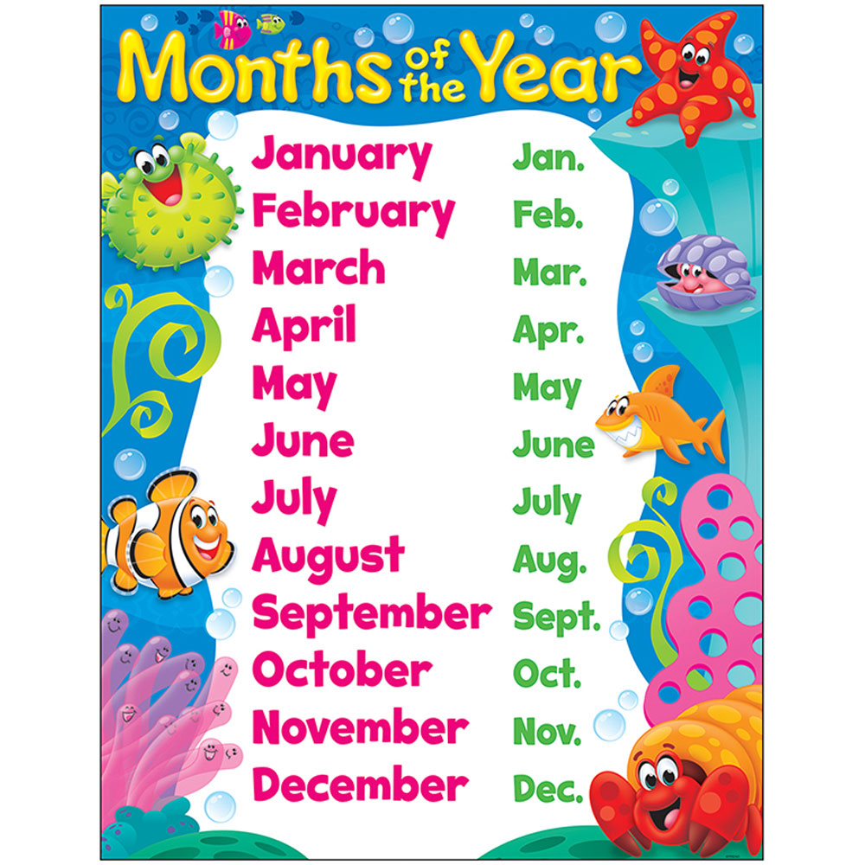

Days of the week
